Detailed Sound everywhere
Sennheiser’s new IE 300 in-ear headphones are built for a high-fidelity listening experience anywhere you go

Sydney, 12 January 2021 – It’s all in the details: Sennheiser’s new IE 300 in-ear headphones have been meticulously crafted to offer nuanced, natural sound on the go. Powered by a refined version of Sennheiser’s 7mm Extra Wide Band (XWB) transducer to ensure a well-balanced sound signature and excellent sonic accuracy, the new IE 300 combines superior sound with premium, professional audio-inspired design.

Passionate audio enthusiasts demand a detailed high-fidelity listening experience not just at home, but everywhere they go. Sennheiser’s new IE 300 features a refined version of the audio specialist’s acclaimed 7mm Extra Wide Band (XWB) transducer, manufactured at the company’s headquarters in Germany, ensuring superior sound quality, with a well-balanced sound signature and excellent sonic accuracy. Every component has been carefully tuned to refine the listening experience: This includes an optimised membrane foil that minimises natural resonances and total harmonic distortion (THD < 0.08 % at 1 kHz, 94 dB), a transducer back volume designed to minimise reflection within the housing and a resonator chamber that removes masking resonances in the ear canal for more refined and detailed treble. Offering a frequency response of 6 Hz – 20 kHz, the IE 300 delivers clear high frequencies with a subtle and warm musicality that brings greater intimacy to vocals.
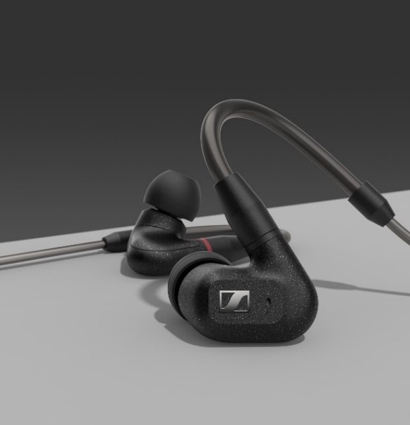

The new IE 300 features a refined version of Sennheiser’s acclaimed 7mm Extra Wide Band (XWB) transducer for superior sound quality

“When you are passionate about audio, details matter. That’s why we meticulously crafted the IE 300 to let listeners hear every nuance in their music,” said Jermo Köhnke, Product Manager at Sennheiser. “The IE 300 is designed to be a companion on the go, while still providing a superior audio experience, no matter your surroundings.”

Audio enhancing comfort
The IE 300 offers exceptional durability and comfort, with a design inspired by the world of professional audio. Its ergonomic features include individually adjustable flexible ear hooks, as well as silicone and memory foam ear adaptors in three sizes (S/M/L). This not only ensures a perfectly secure fit and superb wearing comfort for long listening sessions, but also offers optimum noise isolation, guaranteeing that audio enthusiasts can enjoy undisturbed listening even in busy environments or on the move.
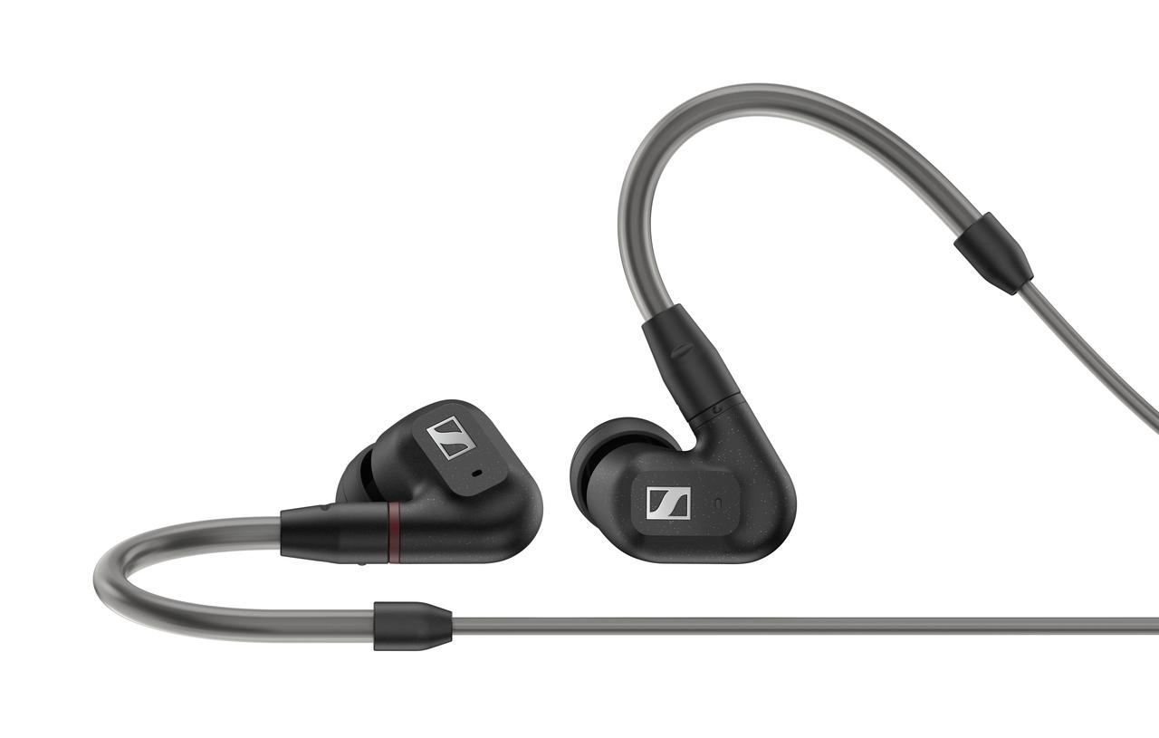

The IE 300’s design is inspired by the world of professional audio

Years of listening pleasure
The IE 300’s supplied 3,5mm cable is reinforced with para-aramid for outstanding stability even after thousands of bend cycles and can easily be replaced for optimal flexibility. For additional strain relief, the high-quality gold-plated Fidelity+ MMCX connector is seated in a recessed, 4.8mm-wide socket in the housing. Balanced cables with 2.5mm or 4.4 connectors are also available as optional accessories. A premium carry case is included for safe and convenient storage.

The Sennheiser IE 300 will be available from March 2021 for AUD $479.95 and NZD $509.95.

About Sennheiser
Founded in 1945, Sennheiser is celebrating its 75th anniversary this year. Shaping the future of audio and creating unique sound experiences for customers – this aim unites Sennheiser employees and partners worldwide. The independent family company, which is managed in the third generation by Dr. Andreas Sennheiser and Daniel Sennheiser, is today one of the world’s leading manufacturers of headphones, loudspeakers, microphones and wireless transmission systems. In 2019, the Sennheiser Group generated turnover totaling €756.7 million. www.sennheiser.com

Local Press Contact
GROUND
Gabby Wallace
T: 0431 045 932
gabby.wallace@groundagency.com

